Other technical SEO details
References
Image download

--
Header image:

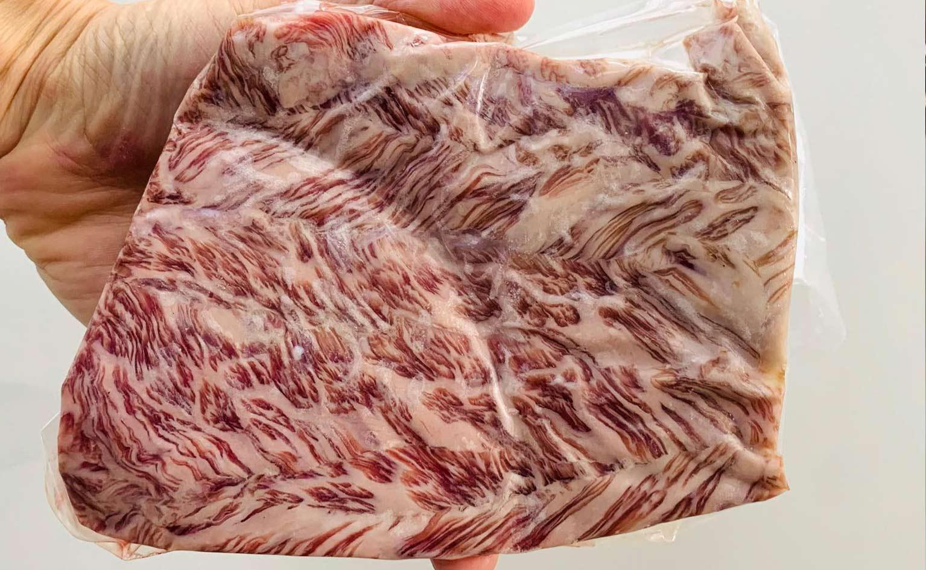

H1: Everything You Need to Know About Wagyu Beef in South Africa
Renowned for its rich flavour profile, tender texture and premium price tag, Wagyu Beef is a sought-after, rare beef around the world and has grown in popularity in recent years in South Africa!

From wagyu beef’s origins to the factors that make this type of beef so delicious - we’ll cover everything you need to know about wagyu beef from A-Z

Let’s dive into more about delicious wagyu beef below!

{
Table of contents:
- What is Wagyu and Wagyu Beef?
- Wagyu Cattle: Where Wagyu beef comes from
- South African Wagyu Beef
- What makes Wagyu Beef special?
- Wagyu beef grading
- Why is Wagyu beef so expensive?
- How does Wagyu beef compare to other types of beef?
- How to cook Wagyu beef:
- Which cuts of Wagyu beef can I find in South Africa?
- Get Wagyu beef in Cape Town!
}

H2: What is Wagyu and Wagyu Beef?
Wagyu are breeds of beef cattle that originated from Japan and produce tender, marbled beef with a high percentage of intramuscular fat. It’s pronounced as wah-gyoo (/ˈwɑːɡjuː/), and directly translates to “Japanese cow”. In Japan, there are four breeds of Wagyu cattle which can be used to produce what is more widely known as just ‘wagyu beef’.

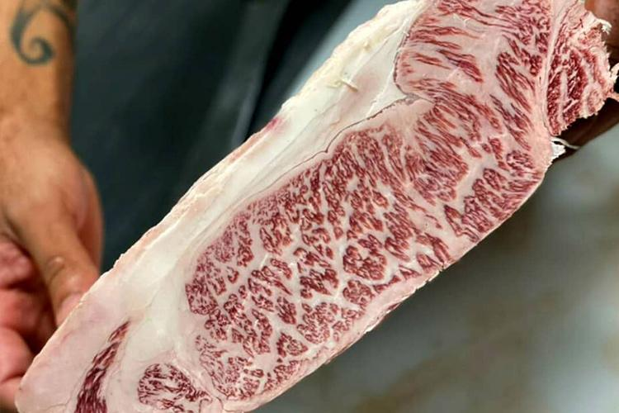

H2: Wagyu Cattle: Where Wagyu beef comes from
As briefly mentioned above, Wagyu beef comes from four breeds of Wagyu cattle that originated from Japan. These Wagyu cattle breeds are:Japanese Black Cattle, Japanese Brown, Japanese Polled and Japanese Shorthorn.

Today, 90% of all fullblood wagyu cattle come from Japan, which still holds the largest population of wagyu cattle overall. Australia contains the second largest population of Wagyu cattle, followed by America.

While you can find Japanese Black Cattle and Brown Cattle in other parts of the world today (provided they have the right lineage), Japanese Polled Wagyu cattle and Japanese Shorthorn Wagyu cattle are not bred outside of Japan.

Modern Japanese cattle are a result of the crossbreeding between Japanese native work cattle with imported cattle breeds such as Brown Swiss, Shorthorn, Devon, Simmenthal, Ayrshire, Holstein and Aberdeen angus cattle breeds. This crossbreeding took place in an attempt to improve the genetics of the native Japanese work cattle and to fulfill demand for high quality beef.

In traditional Japanese culture, Wagyu cattle were prized for their physical endurance. They are also known for their extended lifetime as compared to other types of beef cattle.

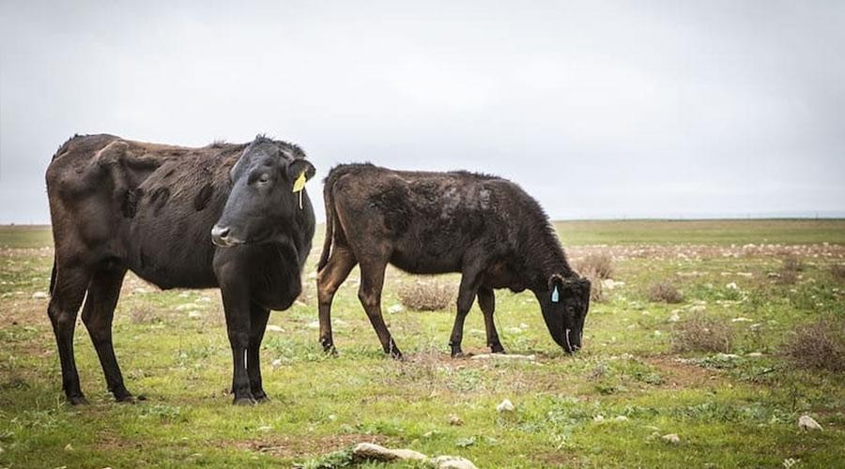

H3: Types of Wagyu Cattle

H4: Japanese Black Wagyu Cattle

Japanese black cattle are widely bred and produce most of the wagyu beef we are familiar with . The cattle are quite short and slight in stature, but are renowned for producing higher grade wagyu beef with premium marbling and make up 90% of all fattened cattle in Japan.
Wagyu beef obtained from Japanese Black Cattle is more widely exported and attains higher prices. Japanese black Wagyu cattle are also incredibly fertile cattle and prized for breeding opportunities.

There are several different lines of Japanese black cattle each with different characteristics:
  - Tajima
    - Used to pull carts and ploughs traditionally, and developed larger forequarters and lighter hindquarters. Tajima are characterised as smaller wagyu cattle, with a slower growth rate - but they produce excellent quality meat with superior marbling.
    - The Tajima black cattle strain is used to produce kobe beef, which is possibly the best variety of wagyu beef available.
  - Kedaka (also known as Tottori)
    - Kedaka are larger wagyu cows that were used in the grain industry and are known for their straight, strong backlines with great growth rates. The grade of wagyu beef obtained from Kedaka cows is generally premium quality.
    - Kedadka originates from the Tottori Prefecture of Japan .

  - Fujiyoshi (also known as Shimane)
    - A medium frame wagyu cattle with a standard growth rate, which produces quality meat but is typically considered less premium than the Tajima strain. Shimane wagyu are often crossbred with Angus cattle.
    - Originates from the Shimane Prefecture of Japan
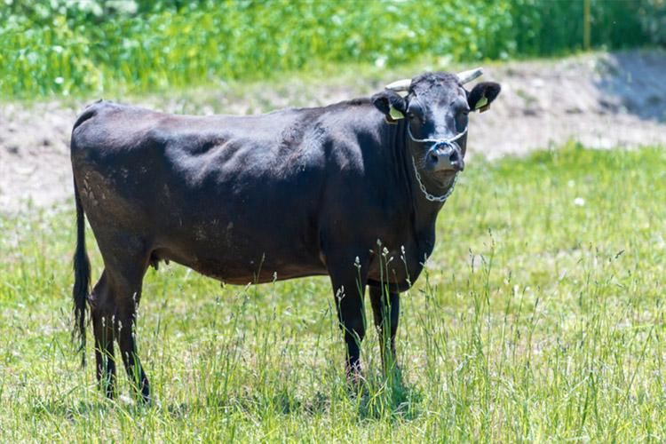

H4: Japanese Brown Wagyu Cattle
Japanese brown wagyu cattle, also known as akaushi, produce what is generally referred to as red wagyu beef. They are larger framed cattle that marble earlier on in their lifetime and don’t remain on feed as long as Japanese black cattle.

Japanese brown cattle were crossbred with Korean Hanwoo, Devon, and Simmental cattle due to the Meiji restoration which involved the introduction of foreign cattle breeds to regions in Japan for genetic improvement.

Although red wagyu’s marbling content may not be up to the very high standards of Tajima Japanese Black Cattle, the intramuscular fat ratio it contains is far higher than other common types of beef cattle breeds and is used to produce wagyu beef in a more cost effective manner, with a slightly firmer texture.

Japanese Brown cattle are commonly raised in the Kumamoto and Kochi Prefectures of Japan.

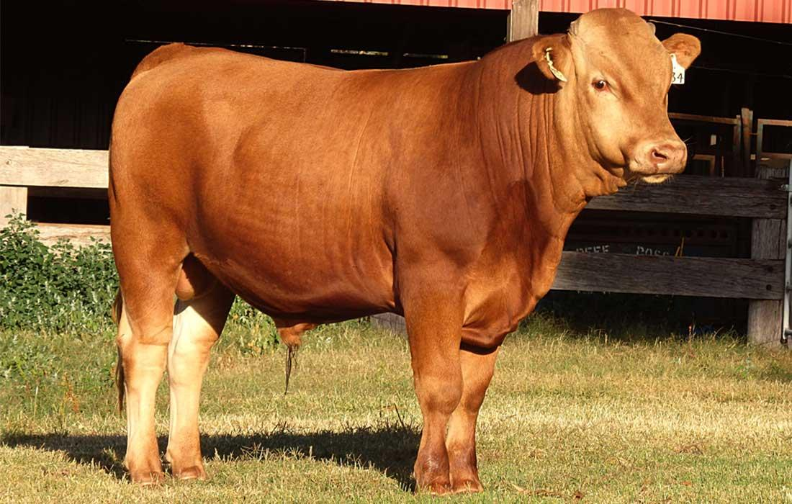

H4: Japanese Polled Wagyu Cattle

Japanese Polled Wagyu Cattle are not bred outside of Japan and are a critically endangered breed of wagyu cattle. Polled Wagyu Cattle were primarily influenced by Scottish Angus cattle.

The conservation status of the Japanese Polled was listed by the FAO as "critical" in 2007 and measures have been put in place by the administration of Yamaguchi Prefecture to protect and preserve the breed and its genetic properties.

Japanese Polled Wagyu Cattle is black in colour without horns and produces high quality wagyu beef cuts with significant marbling.

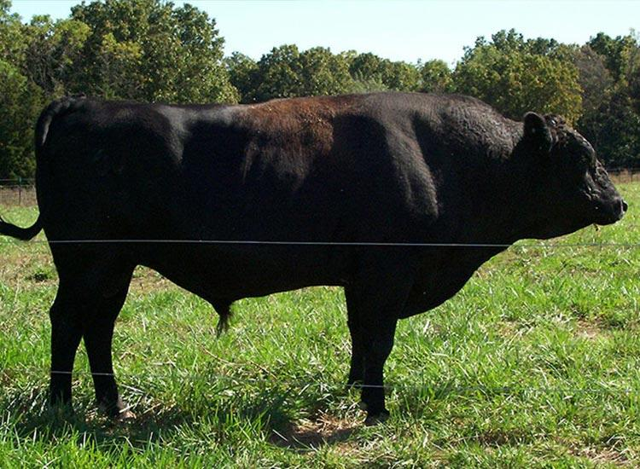

H4: Japanese Shorthorn Wagyu Cattle

Japanese shorthorn wagyu cattle are an incredibly rare breed that is native only to Japan. Japanese Shorthorn Wagyu Cattle makes up less than 1% of all cattle in Japan.

They have reddish brown coats and as the name implies - small horns. Japanese Shorthorns produce fairly lean meat with much less marbling than Japanese black cattle, however, the meat has a rich, savory, umami flavour that is highly desirable.

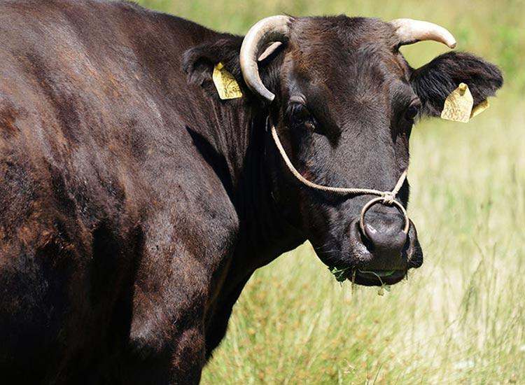

H3: How is wagyu cattle raised?

For wagyu cattle to produce prized wagyu beef, quality living conditions must be structured and maintained throughout their lifespan.

H4: Wagyu calves
Wagyu cattle are typically bred and reared by a specialty breeder until they are 7-10 months old. They are then sold to farmers with a birth certificate to confirm the authenticity of their bloodline.

H4: Grazing
Farmers want to ensure a great quality of life for this luxury cattle breed, and as a result wagyu cattle are allowed to roam and graze freely in spacious pastures. Japanese Wagyu Cattle may only share a pen with 4-5 other cows, whereas other cattle species typically share their space with a much larger group of cows.

H4: Wagyu feeding & environment
Wagyu is typically fed three times a day, with meals consisting of protein rich, high-energy ingredients that may include hay, grain, wheat and other nutrients. This feeding mixture is usually imported and is expensive, increasing the cost of raising luxury Japanese cattle compared to other cattle. Wagyu cattle are never subjected to hormones or antibiotics, from farm to table.

A stress free environment is incredibly important for producing wagyu beef that is tender with marvellous marbling. Stress, and high intensity activities raise the natural adrenaline levels of the animal and can cause tense muscles, stress and as a result - a tough wagyu beef with a lower quality.

Wagyu cattle are usually raised for two to three years, at which time the farmer may expect them to reach a weight of 1500 pounds (680kg) and 50% fat levels.

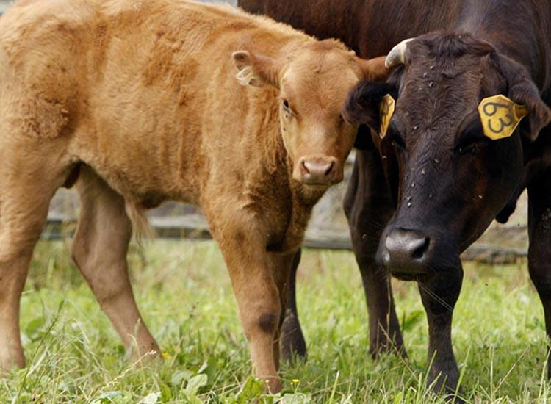

/L.A Farms Alternative/

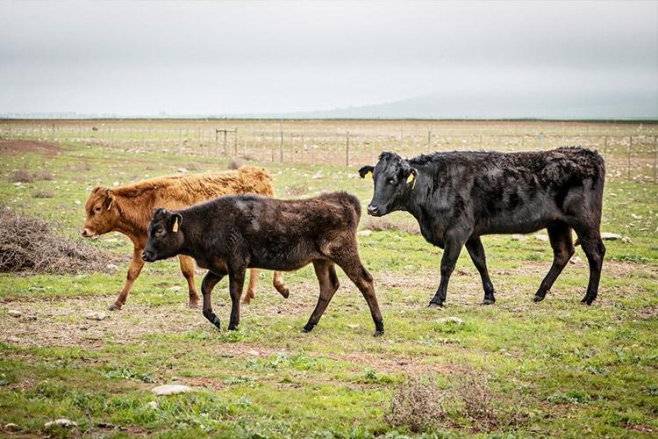

H2: South African Wagyu Beef
While traditional wagyu come from Japan, wagyu can be bred and processed outside of Japan.

Wagyu Beef production is permitted in South Africa, as long as Wagyu Beef is obtained from wagyu sires that are full blood or purebred, and for crossbred wagyu, wagyu sires must have at least 50% Wagyu breed content with a maximum variation of 5%. Wagyu cattle are normally genetically tested by Wagyu South Africa to determine their authenticity for breeding and consumption.

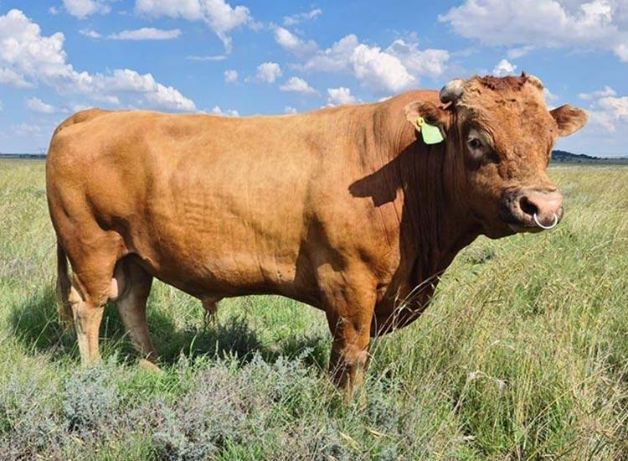

Wagyu South Africa runs the Certified Wagyu Beef Program (CWB) which aims to ensure the integrity of the South African Wagyu beef supply chain and so assure the end customer of product reliability and quality

South Africa is home to around 130 wagyu breeders with an approximate total of 4500 cattle split among them. Of this total, it is estimated that 3000 of these cattle are breeding cattle.
Wagyu cattle were first introduced to South Africa in 1999 when the first embryos were imported from the United States by Brian Angus. South Africa is said to be later adopters of Wagyu beef, following production in England, the United States and Australia.

With wagyu cattle being a resilient, adaptable breed, they can be produced throughout South Africa. Wagyu beef is available via a variety of sources in our country. You can find wagyu beef online, at reputable butchers and even through supermarkets.

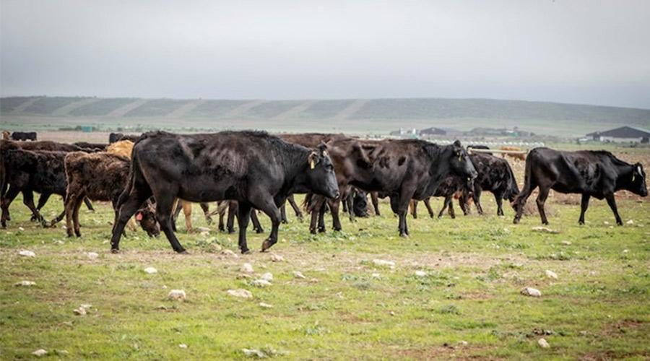

H2: What makes Wagyu Beef Special?

With a beautiful, visually intricate marbling, premium price tag and a strong reputation - people often wonder what makes wagyu beef so special?

Well, other than the incredible care taken in breeding, rearing, feeding, and caring for wagyu cattle - resulting in high quality beef - the marbling and flavour are two key reasons why wagyu beef is sought-after by meat connoisseurs around the world.

H3: Wagyu beef marbling
Answers keyword question.

Intramuscular Fat (IMF) also known as marbling, are the streaks of fat in between portions of red meat throughout wagyu beef. High quality marbling is what provides wagyu beef with its tender texture, and enhances the rich flavour of this premium beef.

Wagyu beef’s marbling is the key component to what makes this rare beef so special. Wagyu beef offers numerous health benefits. It contains 300% more monounsaturated fats compared to normal beef with high levels of oleic acid. Wagyu beef also contains concentrated levels of omega 3 and omega 6 content.

The higher levels of monounsaturated fatty acids in wagyu beef leads to a lower fat melting point which contributes to the tenderness of beef fat, and a richer, more delicious beef flavour.

Wagyu beef is considered heart healthy with the ability to lower low-density lipoprotein (LDL)-cholesterol while increasing high-density lipoprotein (HDL)-cholesterol. Saturated fat levels in wagyu beef are far less than other kinds of red and white meats.

Marbling is not to be confused with fat that may be present on the outside of a wagyu beef cut, and marbling isn’t chewy like fat. The marbling of wagyu beef is an essential factor that influences wagyu beef’s texture, its flavour and how one might grade wagyu beef.

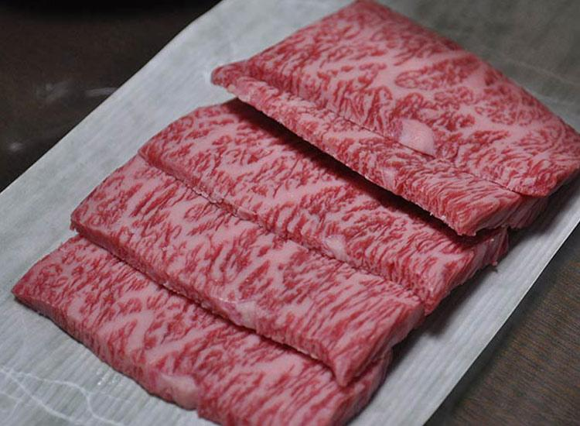

/or/
L.A Farms image (optimized):
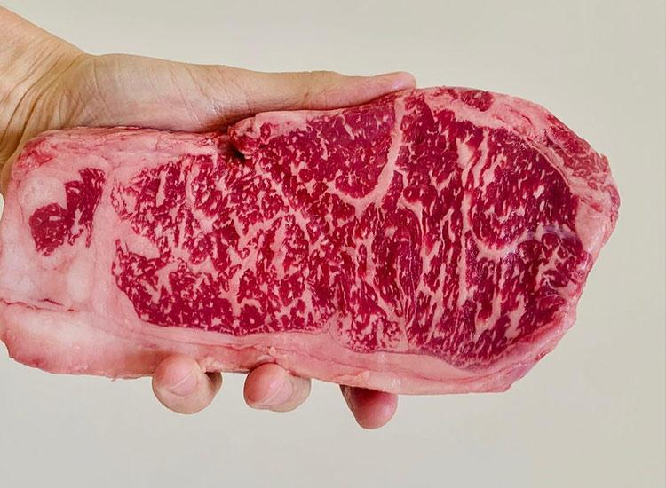

H3: What does wagyu beef taste like?

Wagyu beef has a melt in the mouth feel, with rich umami flavours and a specific sweetness.

Wagyu beef has a delicious, rich flavour profile with intense beef notes and a succulent feel on the palate. The flavour profile of prime wagyu may alter depending on where it was raised and its living conditions.

For example, some chefs feel wagyu beef produced in America has a more intense beef flavour and likens to Angus beef, whilst Japanese wagyu may have a lighter flavour with delicate hoppy undertones.
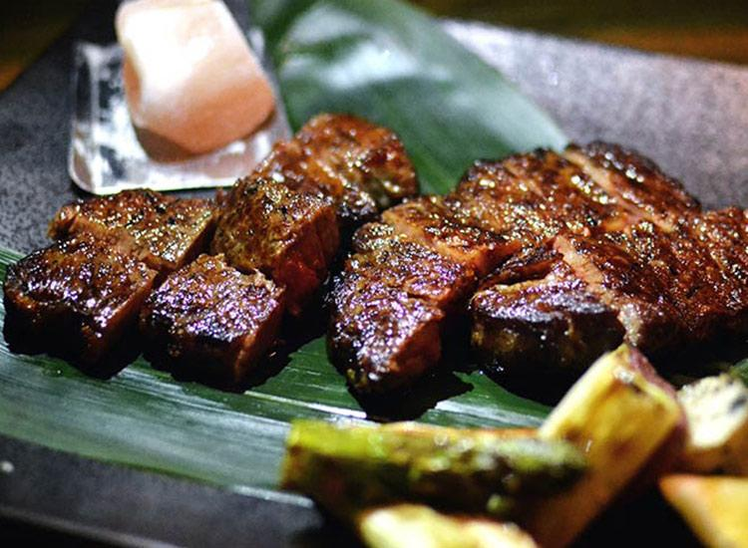

H2: Wagyu beef grading
Answers keyword question.
Wagyu is graded differently depending on where the meat cuts were produced. Which is something important to keep in mind when buying Wagyu beef.

Generally the grading of wagyu beef is determined by beef’s quality grade and the yield grade. The quality grade is usually a numerical figure between 1 and 5, whilst the yield grade is split into Grade A, B and C categories. The highest grade of Wagyu beef would be A5 and the lowest C1.
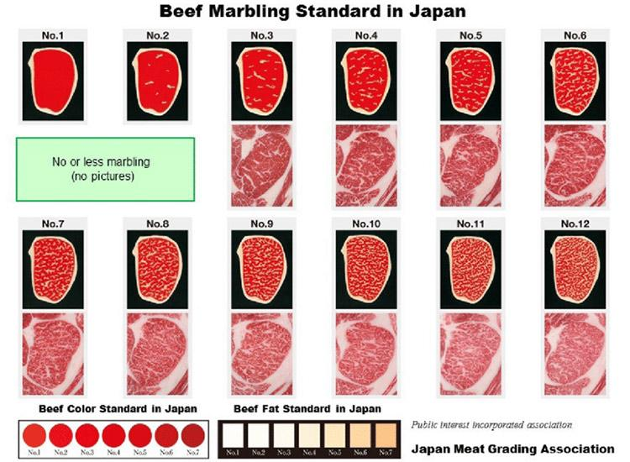
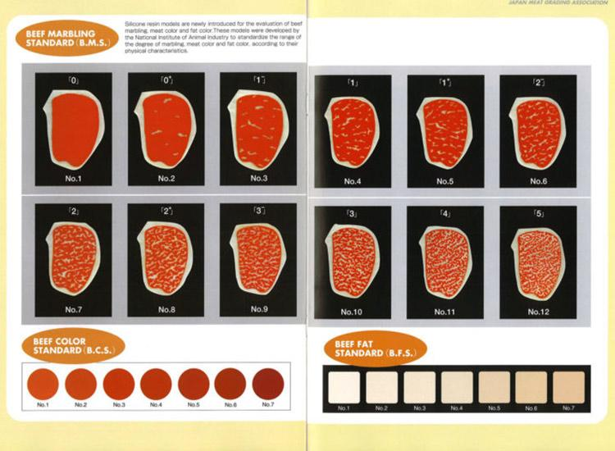
/or/

H4: Japanese Wagyu Beef Grading System (JMGA)

The Japanese take Wagyu Beef grading very seriously and the system provides wagyu beef cuts with a yield and grade score. The yield score (A, B, or C) is based on the ratio of meat to actual carcass weight with a score of A being higher than standard yield.

They also assign a meat quality grade which is a numerical value between 1 and 5 based on the following criteria/scores:

- Beef Marbling Score (BMS)
Arguably the most important score, marbling is scored between 1 and 12 with a score above 10 being highly prized wagyu beef. A score of 10 and above is very highly sought after.

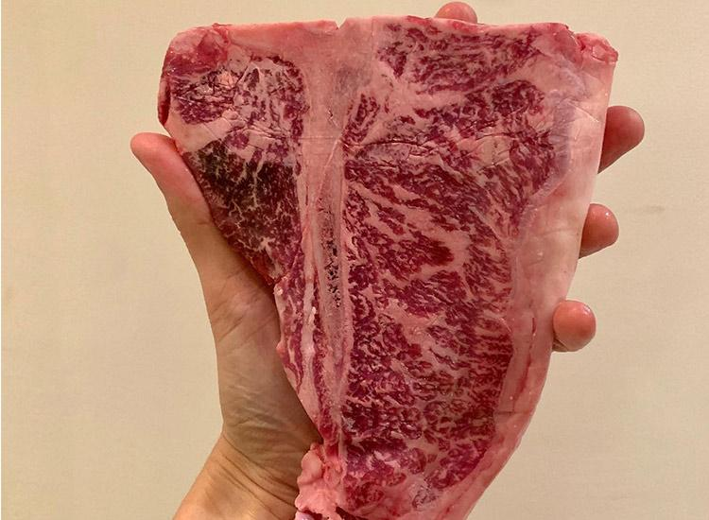

- Beef Color Standard (BCS)
Colour and gloss is scored according to a 7 colour chart with colours 3-5 being the most desirable and a wider range of 1-7 being the least.

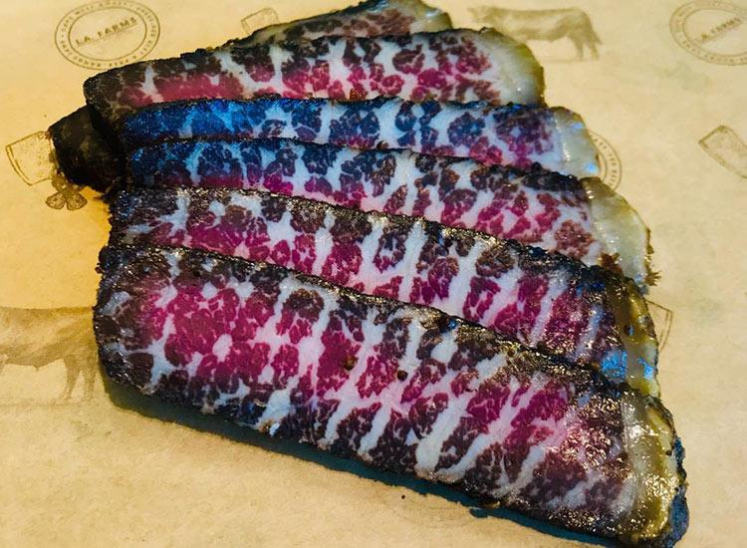

- Beef Fat Standard (BFS)
Fat is also scored against a colour chart of 7 colours ranging from white (1) to more yellow(7). Colours 1 to 4 are the most desirable.

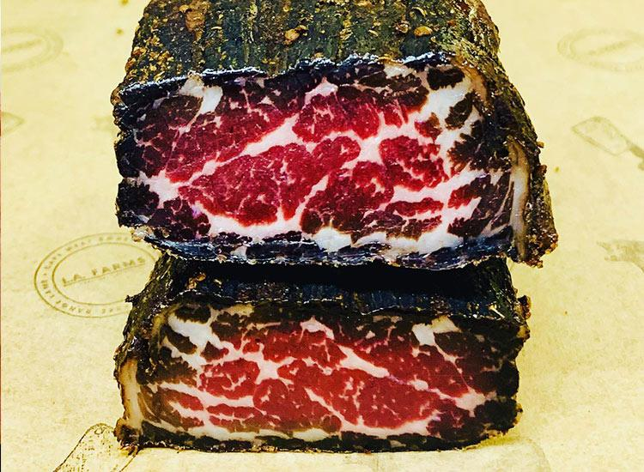

- Firmness & texture
The meat firmness and texture are graded simply from 1-5 with 5 corresponding to excellent texture and firmness.

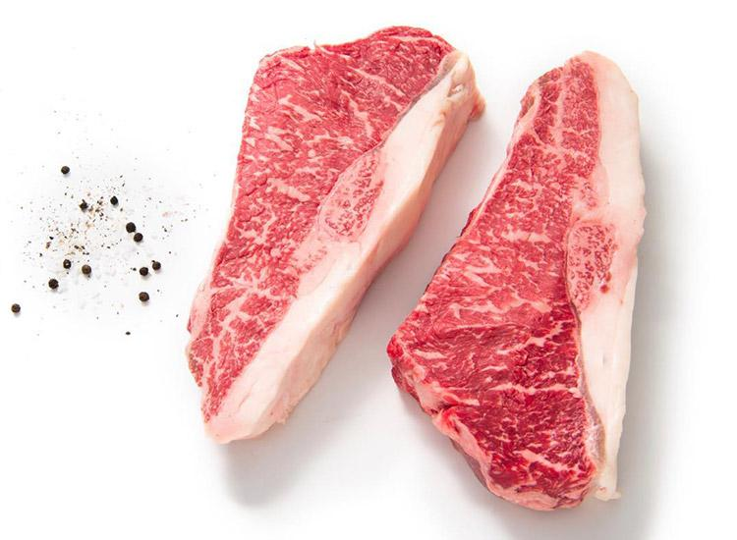

Each score is then converted to a grade between 1-5 and the overall quality is graded. In order to qualify as highest quality, A5 Japanese Wagyu, beef must be graded as Grade A for yield and Grade 5 in all of the scores listed above (BMS, BFS, BCS, firmness and texture)

H4: South African Wagyu Beef grading System

The Wagyu beef grading system used in South Africa is very similar to that used in Japan. However, the marbling score (BMS) is ranked out of 10, not 12. The Certified Wagyu Beef Program (run by Wagyu South Africa) makes use of an MIJ camera that measures marbling of the rib eye area and marbling fineness. The marble score classification ranges from a marble score 1 to 10, with 1 being the lowest and ten the highest..

H2: Why is Wagyu beef so expensive?
If you’ve ever shopped around for cuts of wagyu beef, you’ll know that wagyu beef is expensive - but worth it every penny!
Wagyu beef’s high quality, enticing visual appeal and acclaimed flavour profile are just a few surface level reasons why wagyu beef fetches a higher price tag than other kinds of premium beef produced around the world.

Let’s find out more about what influences the price of wagyu beef and how it rivals (and beats) other beef cuts!

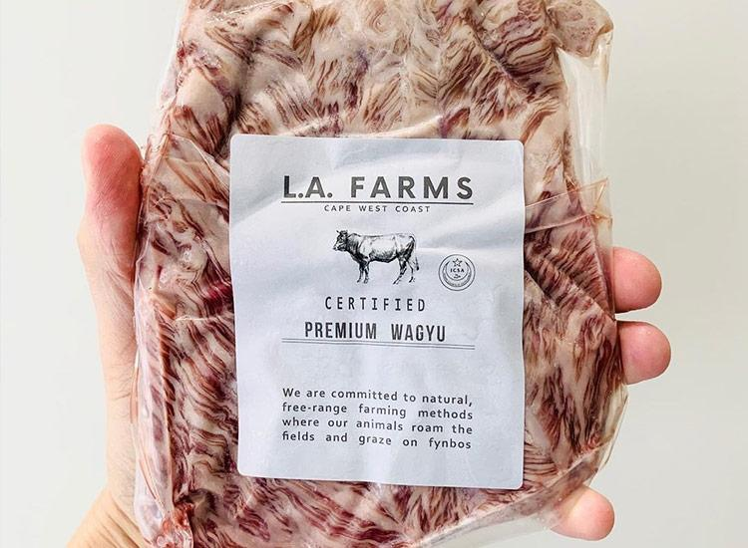

H3: What is the price of wagyu beef in South Africa?
The price of Wagyu beef in South Africa is largely dependent on the marbling score of the wagyu beef, as well as the type of cut advertised.

The price of wagyu meat has come down significantly since 2009 when a wagyu steak cost R700 per 300g on average (Cape Town figure). Today, wagyu beef is far less expensive than it was 12 years ago, making it even more worthwhile to feature at special occasions complimented by great food!

At buyfresh we sell Wagyu beef and our burger patties are priced at roughly R240 per kilo and are minimum BMS 5+ grade. Our wagyu rump cut is around R950 per kilogram and our wagyu sirloin steak cut is around R1500 per kilogram, while our wagyu ribeye steak is roughly R1600 per kilogram, with varying high BMS+ grades (in the minimum range of BMS 6-8+).
Our wagyu cubes and wagyu stir fry cuts retail for around R320 per kilo (minimum BMS 5+)
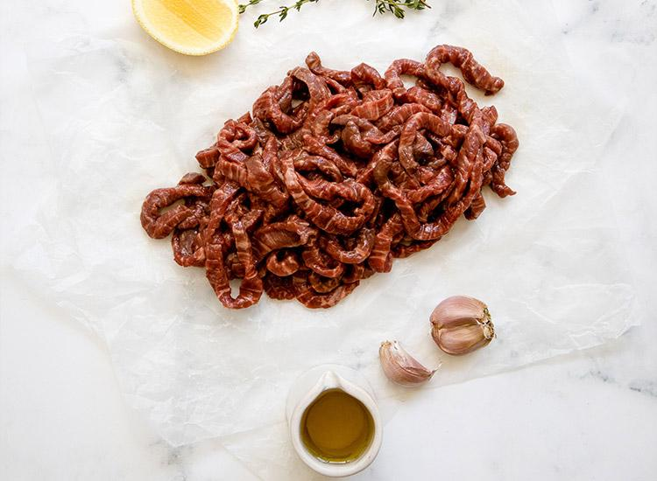

H2: How does Wagyu beef compare to other types of beef?
We’ve chatted a lot about what makes wagyu beef so incredibly special in terms of taste, texture and breeding lineage - but let’s find out how this Japanese beef compares to other types of favourite beef!

H3: Wagyu beef vs Angus beef

For starters, Angus Beef is produced using a single cattle breed known as Aberdeen Angus, hailing from Scotland, whilst wagyu beef is produced from up to 4 breeds of wagyu cattle native from Japan.
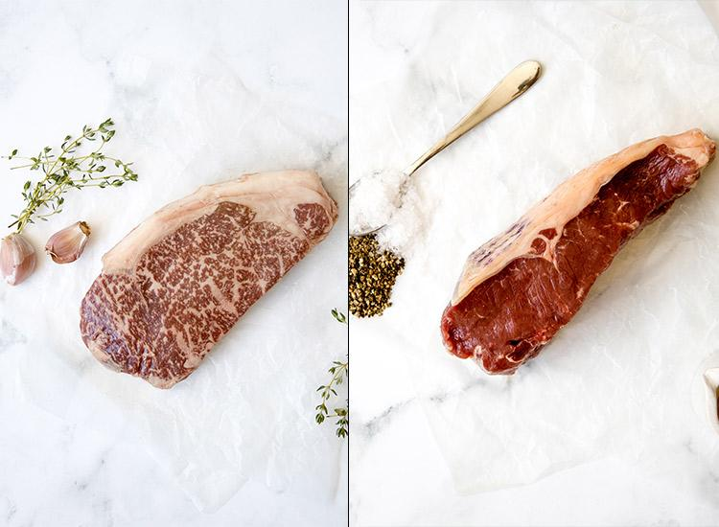
Marbling
Like Wagyu cattle, Angus cattle are also very resilient and are capable of enduring bitter scottish winters. Angus cattle have significant muscle content, which contributes to their quality marbling. Although Aangus cattle have high IMF content or marbling compared to other kinds of beef, wagyu beef definitely has the edge, with a higher concentration of intramuscular fat, and as a result, a more tender texture and a striking, full-flavour profile.

Taste
That being said, Angus beef does have an exceptional flavour profile in its own right and is a tender red meat that melts in your mouth. Angus beef contains high levels of Iron and B Vitamins like Niacin, Whilst wagyu beef contains 3-4 times more monounsaturated fatty acids, as well as concentrated omega 3 and omega 6 ingredients, and the lowest cholesterol levels present across other types of red and white meat.

Availability
While Angus beef originated from Scotland, it is now found produced in a variety of different regions across the world, in Australia, the United States and South Africa. The same can be said for wagyu beef.
While both Angus beef and Wagyu beef carry higher price points than other conventional beef obtained from more common breeds, Wagyu beef definitely takes the edge if you’re comparing these two premium beefs.

H3: Does Wagyu beef have to be free-range and grass fed?
Free-range and grass-fed are terms that relate to how cattle is raised - being either free to roam a pasture, or fed a grass based diet respectively.

Whilst most wagyu cattle breeds are free-range and grass-fed, in order to maximise their health, reduce stress levels and produce a beef that is exceptional quality as an end result, not all Japanese cattle considered to be wagyu beef are free-range or grass-fed.

A strain of Japanese Black Wagyu cattle known as Tajima which can be used to produce Kobe beef is unlikely to be free range or grass fed when raised with intent to produce Kobe beef in two prefectures in Japan. In this instance, Tajima may be subjected to an altered diet in an effort to produce higher marbling content plus they may be kept indoors and even massaged at regular intervals to distribute their subcutaneous fat.

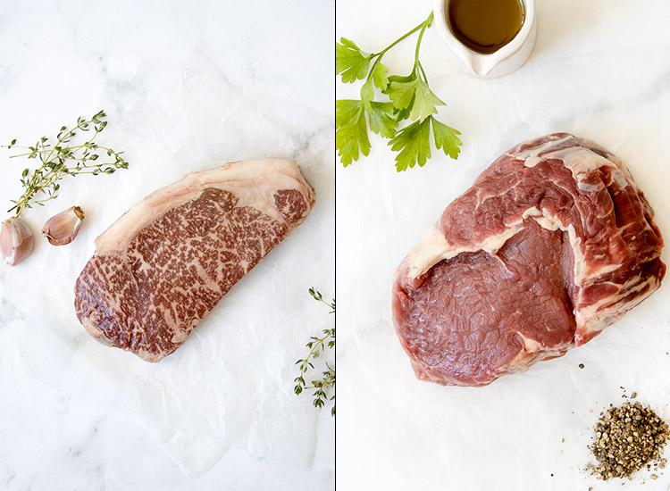

H3: Wagyu beef vs Kobe Beef

Kobe beef is produced from the Tajima strain of Japanese Black Cattle and is a prized and superior form of Wagyu.

For Wagyu meat to be certified as Kobe beef, Japanese Black Cattle must be born, raised, slaughtered and processed in Hyogo Prefecture in Japan, at the specific age of between 28 and 60 months of bullock or not calved cow. Kobe beef must be produced from steers (young neutered male cattle primarily raised for beef) or from castrated bulls.

In addition, the carcass needs to produce a meat quality score of A or B, produce a yield score of at least 4 or 5 and Beef Marbling Score (BMS) of 6 or higher.

Kobe Beef is a prized rare beef across the world, attaining a high price tag and is renowned for its exceptional marbling, tenderness and delicate but abundant flavour profile.

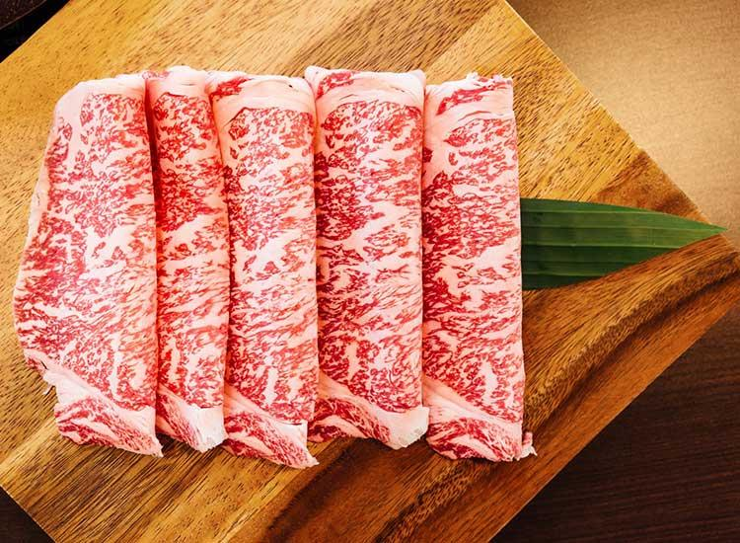

H2: How to cook Wagyu beef:

Placeholder in interim before video.

Once you have your hands on wagyu beef, you’ll want to know exactly how to cook it and ensure that it is prepared perfectly to produce the full range of flavours and tenderness you’ve heard all about.

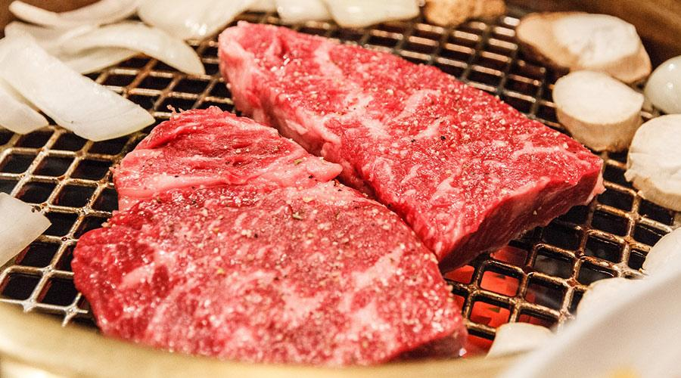

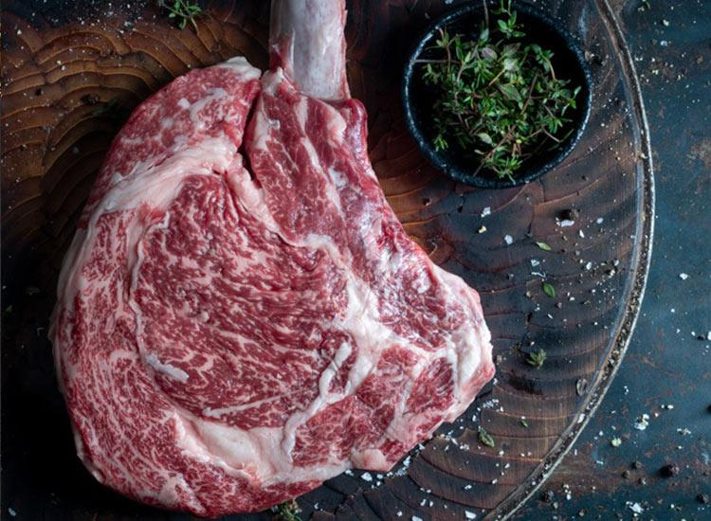
Or L.A Farms alternative(can’t find any suitable cooked wagyu alternative):

H3: Storage of Wagyu meat
You should ideally store wagyu frozen if you’re not planning to cook it right away, and ensure that it spends minimal time exposed to air to avoid freezer burn. When ready to cook, make sure to thaw frozen wagyu beef cuts for at least 6 hours per 500g of meat.

H3: How to cook a Wagyu steak
When cooking wagyu at home it’s important to not overcook wagyu beef, and some of the best chefs recommend serving wagyu beef fairly rare to ensure the meat remains tender. Another key tip is to not overseason your wagyu, to bring out the delicate full-bodied natural flavours in wagyu beef.

H4: Preparing the steak
Before you actually start cooking, it is a good idea to dry your wagyu steak by dabbing with a paper towel, or if you have time by leaving it uncovered in the fridge on a baking rack for 8 hours or until dry to the touch.

Once dry you should lightly salt your steak and leave to come to room temperature for at least 1 hour before cooking. This helps the meat retain moisture, ensures more even salt distribution, and more even cooking when the steak is all the same temperature.

H4: Now you are ready to cook!
To start, preheat a cast iron skillet or pan over high heat, and lubricate the pan with a small quantity of butter or olive oil. Some chefs recommend cutting a bit of fat from the edges of your wagyu beef cut to use to grease the pan.

Once hot, sear the steak in the pan. For a rare finish, you may wish to sear wagyu for at least 3 minutes a side, and 4 minutes per side for a medium finish. Once cooked remove from the pan and let your cooked wagyu steak rest for at least 5-10 minutes before diving in. Allowing your wagyu to rest will allow your meat fiber’s to relax, widen, reabsorb those delicious juices. Once rested, slice or serve as desired!

We recommend serving with sauteed mushrooms and/or accompanied by vegetables such as roasted broccoli, brussel sprouts, and asparagus.

H2: Which cuts of Wagyu beef can I find in South Africa?
While many years ago it might have been more of a challenge to find varieties in wagyu beef, today, a whole range of wagyu beef cuts with varying degrees of quality are available in South Africa.

Typically, wagyu cuts like sirloin and rump steaks are higher grade wagyu than cuts of wagyu used to produce wagyu burgers, sausages, mince and even biltong.

Let’s find out about different types of wagyu beef available in South Africa below!

{An infographic like this might be useful as a visual for the section}

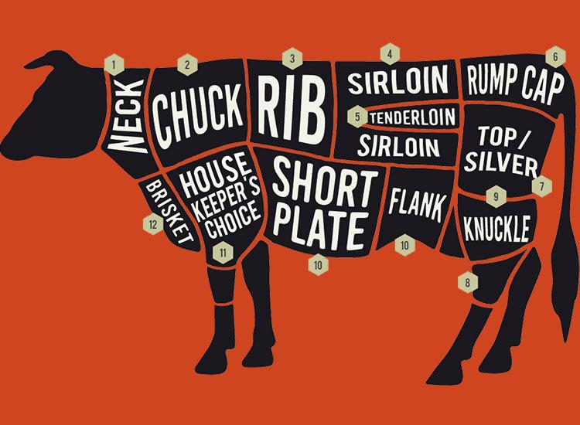

H3: Wagyu burgers

Wagyu beef burgers are of course made from a ground form of wagyu beef. You could choose to buy wagyu burger patties ready-made, or create your own using ground wagyu beef, provided you have the know-how to do so. Wagyu burger patties are generally priced in the region of R200-250 per kilogram.

Wagyu beef burgers are generally cooked for 3 to 5 minutes per side over high heat, until they are a light golden brown colour. Check out our premium wagyu burgers in our shop!

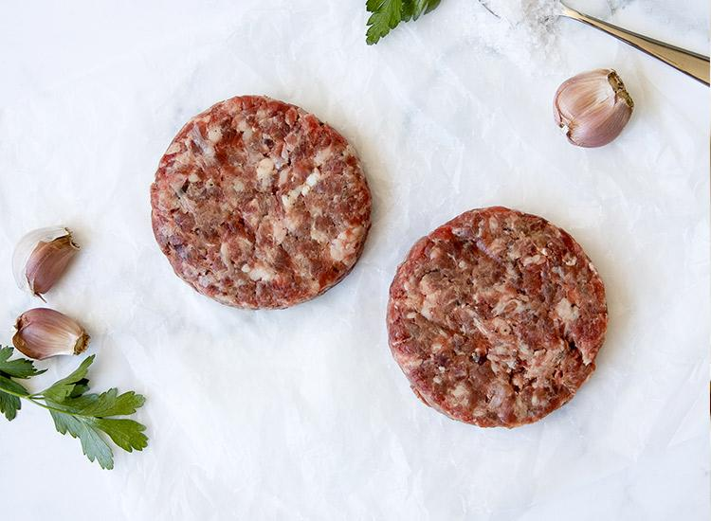

H3: Wagyu Beef Sausages

Wagyu beef sausages are perfect for the braai, with high marbling and exquisite flavour and are priced between R200 to R250 per kilogram.

The filling inside wagyu beef sausages consist of a blend of different cuts of wagyu meat, and the high fat content of Wagyu beef makes for a delicious and tasty sausage to impress your family and friends with.

You can also find Wagyu beef bangers in South Africa which retail around the same price point per kilogram. Check out Wagyu Beef Sausages in our shop!

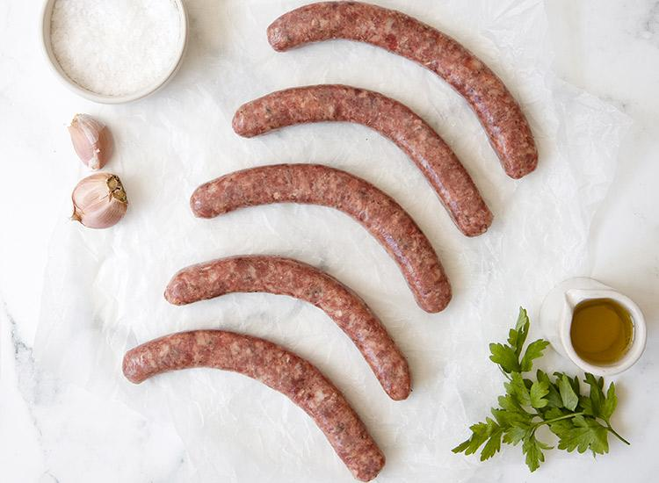

H3: Wagyu Beef Mince

Wagyu beef mince is a less expensive, versatile wagyu beef product that can be included in a variety of dishes.

Wagyu beef mince to make extra tasty bolognese, meatballs or an extra special bobotie!

Wagyu beef mince is usually priced in the region of R200 to R250 per kilogram. You can purchase Wagyu Beef Mince in our store for R238.95.

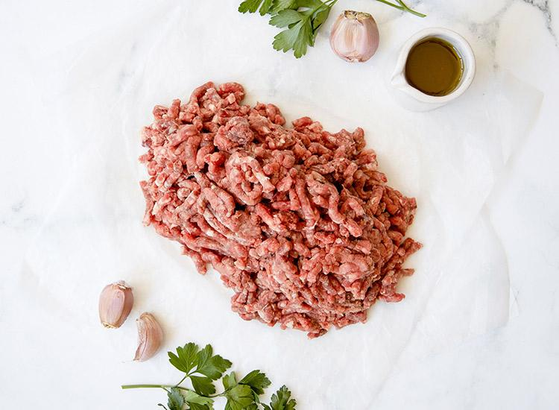

H3: Wagyu Biltong

Wagyu biltong is created using carefully marinated wagyu meat and a delicate spice blend and retails in the region of R850 per kilogram.

Although biltong is by dried by definition, the flavours you may encounter with wagyu biltong may be overwhelmingly succulent, with a tender, melt-in-the-mouth flavour. Checkout premium Wagyu Beef Biltong in our shop

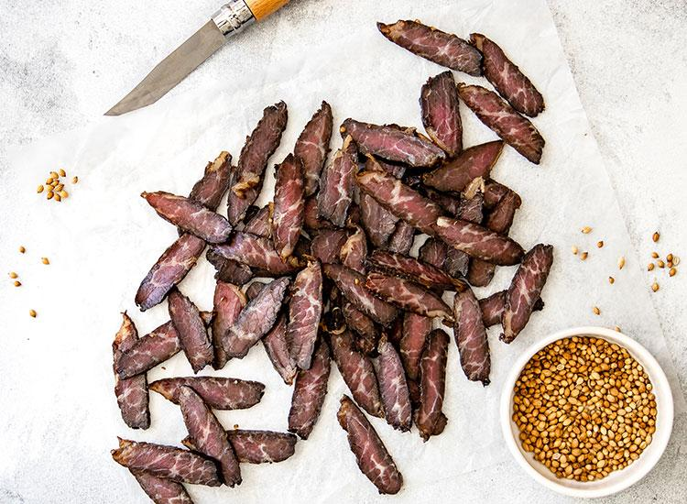

H3: Wagyu Steaks
Wagyu steaks are one of the most popular forms of wagyu and for obvious reasons!
Wagyu steaks typically contain higher intramuscular (marbling) content and are produced from higher quality meat grades and yield grades of wagyu cattle.

The end result is a more exciting mealtime experience, with an exquisite tenderness and rich flavour accompanying every bite of your wagyu sirloin or rump steak - no tough dry steak here!

The price of wagyu steaks can vary, and may retail in the region of anywhere from R700 per kilogram to over R1500 per kilogram.

Buy our Wagyu Ribeye Steak, Wagyu Sirloin Steak or Wagyu Rump Steak online from our shop!

{pic from website backend - need logins}
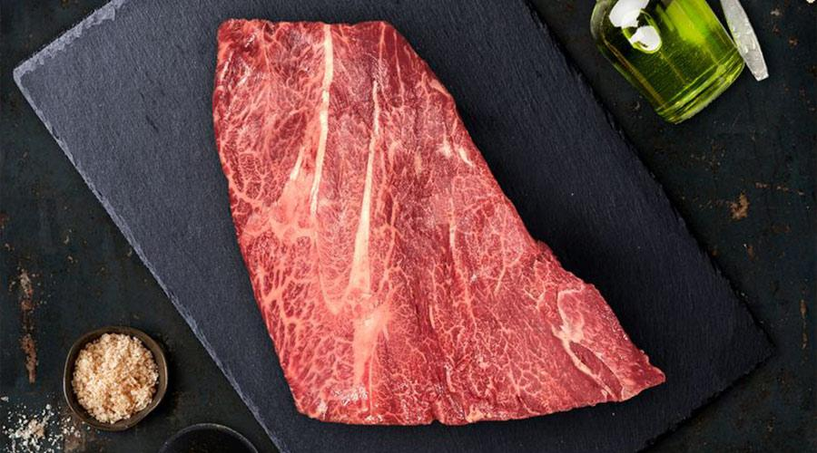

H2: Get Wagyu beef in Cape Town!
So, you’ve found out everything you need to know about wagyu beef right off the bat - and you’re probably pretty keen to give wagyu beef a try!

We offer a variety of Wagyu beef cuts obtained from exceptional quality, certified South Africa producers of authentic Wagyu beef. We only stock premium Wagyu beef that typically contains cuts with a minimum marbling score of 5, with sirloin and rump steaks attaining a BMS grade of at least 6-9.

Expand your horizons with delicious succulent, tender wagyu beef, and enjoy a melt-in-the-mouch experience perfect for all types of meat connoisseurs.

Order Wagyu beef online in Cape Town from buyfresh today!

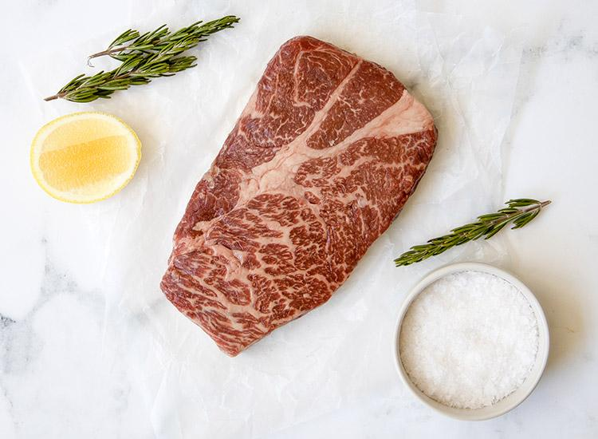

Technical SEO for post:
Meta title:Everything About Wagyu Beef in South Africa | buyfresh /or/
Complete Guide to Wagyu Beef in South Africa | buyfresh
Meta description: (127): All about Wagyu Beef in South Africa, from what Wagyu beef is to what makes Wagyu beef so special! Read about Wagyu Beef in SA!

Read about Wagyu Beef in South Africa. From what Wagyu beef is to what makes Wagyu beef so special, how to judge Wagyu & more! (126 char)

URL path: https://buyfresh.co.za/wagyu-beef-south-africa

OG image: https://buyfresh.co.za/wp-content/uploads/2019/06/Wagyu-Rump-L.A.-Farms-1.jpg

Image alt text: set in comment next to each image

-

References:

General
- https://www.farmersweekly.co.za/animals/cattle/wagyu-cattle-producing-kobe-beef/
- https://steakschool.com/learn/why-wagyu-beef-is-so-good/
- https://ribsandburgers.com/au/news/3-reasons-why-wagyu-is-the-best-beef-in-the-world/
- https://robbreport.com/food-drink/dining/what-is-wagyu-beef-luxury-steak-2855767/
- http://wagyu.org.za/wp-content/uploads/2018/12/2018-Wagyu-Handbook-South-African-Edition.pdf
- https://www.timeslive.co.za/sunday-times/lifestyle/food/2020-11-12-is-sas-wagyu-beef-the-same-as-japans-famously-expensive-kobe/#:~:text=Abattoirs%20use%20specialised%20technology%20to,for%20the%20much%2Dprized%20steak.

Health benefits and nutritional content:
- https://www.ncbi.nlm.nih.gov/pmc/articles/PMC5243954/#r011
- https://meatthebutchers.com/wagyu-beef-nutritional-facts/#:~:text=Per%20100%20grams%3A&text=Wagyu%20has%20been%20compared%20to,higher%20concentrations%20of%20oleic%20acid.

Genetics & types of wagyu cattle
- https://www.lonemountaincattle.com/about-wagyu/genetic-lines-of-wagyu/
- https://en.wikipedia.org/wiki/Wagyu
- http://wagyu.org.za/wp-content/uploads/2018/12/2018-Wagyu-Handbook-South-African-Edition.pdf
- https://gurunavi.com/en/japanfoodie/2017/04/a-guide-to-wagyu.html?__ngt__=TT119299230005ac1e4aec02jak5bUGwuayblxjuaSYn0T

Why is wagyu beef so good?
- https://steakschool.com/learn/why-wagyu-beef-is-so-good/

Cooking
- https://blogs.lonemountainwagyu.com/how-to-cook-a-wagyu-beef-burger-in-the-kitchen

Price
- https://www.food24.com/what-is-wagyu-beef-and-why-the-hefty-price-tag/
- https://www.rd.com/article/why-is-wagyu-beef-so-expensive/

Wagyu vs Angus

- https://ownthegrill.com/wagyu-vs-angus-beef/
- https://www.organicfoods.com.au/the-difference-between-angus-and-wagyu-beef/
- https://steakschool.com/learn/what-is-angus-beef/#:~:text=What%20is%20the%20difference%20between%20Angus%20and%20wagyu%20beef%3F&text=They're%20both%20known%20as,from%20a%20range%20of%20breeds.

Kobe Beef

- https://japanology.org/2016/09/what-makes-kobe-beef-the-worlds-best/#:~:text=Kobe%20cattle%20are%20not%20%E2%80%9Cfree,for%20a%20variety%20of%20reasons.&text=Considering%20that%20they%20are%20being,eat%20because%20of%20the%20heat.

buy fresh cuts:

- https://buyfresh.co.za/product-category/meat-poultry/beef/wagyu-beef/

Removed:

